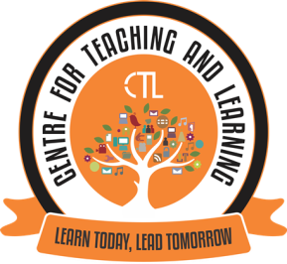

The Centre for Teaching Learning (CTL) organised the following Activities/Programmes in the Month of April 2021.
- An Orientation cum Training programme on using OBE Portal. The main objective of this session was to demonstrate the OBE portal and give hands-on training to College faculty on the same. It was conducted on 17th april, 2021 in the Lower Auditorium and attended by 4 Faculty. Assistant Professors Ms. Dikshita Aroskar and Ms. Ashweta Anand Fondekar from the Department of Computer Science were the resource persons for the same. An LOCF Portal Manual was also prepared so that Faculty can use it as a resource.
- Expert FDP Webinar Series VI on the topic “Perspectives of NEP 2020: Technology in Higher Education” on 29th April, 2021 via GMeet for the college teaching faculty.
Dr.R.C.Sharma, Associate Professor n Instructional Design and Educational Technology was the Resource Person at this FDP.
This FDP focussed on certain terminologies/annotations used in the NEP; It also focussed on Learning Paths and Competencies so that Faculty can use techniques in teaching, learning and evaluation so that we can create students who are self directed lifelong learners. The FDP webinar Series V was attended by 28 college Faculty.

FDP VI Photographs
The Resource Person Dr.R.C.Sharma delivering the FDP and Answering Particpant Questions
